 

# GENERATIVE ADVERSARIAL NETWORK (GAN) FOR GENERATING HANDWRITTEN DIGITS

# A MINI PROJECT REPORT

***Submitted by***

**YATHINDRA PRAVANAN TV (311520104063)**

***in partial fulfillment for the award of the degree of***

**BACHELOR OF ENGINEERING**

***IN***

# COMPUTER SCIENCE AND ENGINEERING MEENAKSHI SUNDARARAJAN ENGINEERING COLLEGE,

**KODAMBAKKAM, CHENNAI-24**

**ANNA UNIVERSITY: CHENNAI 600 025**

# MAY 2023

ANNA UNIVERSITY: CHENNAI 600 025

**BONAFIDE CERTIFICATE**

Certified that this project report “ **GENERATIVE ADVERSARIAL NETWORK (GAN) FOR GENERATING HANDWRITTEN DIGITS**” is the bonafide work of “ **YATHINDRA PRAVANAN TV (311521104063)** ” who carried out the project work under my supervision.

**SIGNATURE SIGNATURE**

Dr.S.Aarthi,M.E.,Ph.D Mrs. P.Revathi,M.Tech.

**HEAD OF THE DEPARTMENT ASSISTANT PROFESSOR**

Computer Science and Engineering Computer Science and Engineering

Meenakshi Sundararajan Engineering College Meenakshi Sundararajan Engineering College

No.363 , Arcot Road, Kodambakkam , No.363 , Arcot Road, Kodambakkam ,

Chennai- 6000024 Chennai- 6000024

Submitted for the project viva voce of Bachelor of Engineering in Computer Science and Engineering held on __ .

# INTERNALEXAMINER EXTERNALEXAMINER

**ACKNOWLEDGEMENT**

First and foremost, we express our sincere gratitude to our Respected Correspondent **Dr. K. S. Lakshmi**, our beloved Secretary **Mr .N.Sreekanth**, Principal **Dr. S. V. Saravanan** and Dean Academics **Dr .K. Umarani** for their constant encouragement, which has been our motivation to strive towards excellence.

Our primary and sincere thanks goes to **Dr. S. Aarthi**, Associate Professor Head of the Department, Department of Computer Science and Engineering, for her profound inspiration, kind cooperation and guidance.

We’re grateful to **Mrs. P. Revathi** ,Internal Guide, as our project coordinators for their invaluable support in completing our project. We are extremely thankful and indebted for sharing expertise, and sincere and valuable guidance and encouragement extended to us.

Above all, we extend our thanks to God Almighty without whose grace

and blessing it wouldn’t have been possible.

# ABSTRACT

Generative Adversarial Networks (GANs) represent a breakthrough in artificial intelligence, particularly in the domain of image generation. In the specific task of generating handwritten digits, GANs employ a dual-network architecture comprising a generator and a discriminator. The generator aims to produce synthetic handwritten digits, while the discriminator learns to distinguish between real and generated digits. Through an adversarial training process, the generator continually refines its output to produce increasingly realistic digits, while the discriminator improves its ability to differentiate between real and fake examples.

Training GANs for generating handwritten digits typically involves utilizing digit datasets such as MNIST or SVHN. These datasets provide a large collection of labeled handwritten digits for both training the generator to produce realistic samples and training the discriminator to accurately classify real and generated digits. By leveraging these datasets, GANs can learn the underlying patterns and characteristics of handwritten digits, enabling them to generate novel and high-quality examples that closely resemble real handwritten digits.

Overall, GANs offer a flexible and powerful framework for generating handwritten digits with various styles and characteristics. By adjusting the network architecture, training data, and hyperparameters, GANs can produce diverse sets of handwritten digits that mimic different handwriting styles and variations. This flexibility makes GANs invaluable in tasks requiring the generation of handwritten digits, including digit recognition systems, data augmentation for training machine learning models, and artistic applications such as font generation and handwriting synthesis.

|  |  |  |
| --- | --- | --- |
|  | **TABLE OF CONTENTS** |  |
| **CHAPTER**  **NO.** | **TITLE** |
|  | **ABSTRACT** |  |
| **1** | **INTRODUCTION** |  |
|  | * 1. PROJECT OVERVIEW   2. ABOUT THE PROJECT |  |
|  | 1.3 PURPOSE |  |
|  | * 1. PROBLEM STATEMENT |  |

# LITERATURE SURVEY

# SYSTEM ARCHITECTURE

# SYSTEM ARCHITECTURE

# HARDWARE REQUIREMENTS

# SOFTWARE REQUIREMENTS

# IDEATION AND PROPOSED SOLUTION

# PROBLEM STATEMENT DEFINITION

# IDEATION AND BRAIN STORMING

# REQUIREMENTS ANALYSIS

# FUNCTIONAL REQUIREMENTS

* 1. NON FUNCTIONAL REQUIREMENTS

# PROPOSED SYSTEM

# CODE

# OUTPUT

# PROJECT DESIGN

# DATFLOW DIAGRAM

# RESULTS

# 10.1 PERFORMANCE METRICS

# ADVANTAGES AND DISADVANTAGES

# CONCLUSION AND FUTURE SCOPE

* 1. CONCLUSION
  2. FUTURE SCOPE

**13 APPENDIX SCREENSHOTS**

**14 REFERENCES**

**15 CERTIFICATE**

**Chapter 1**

# INTRODUCTION

# Handwritten digit recognition has long been a cornerstone task in machine learning and artificial intelligence. The ability to accurately classify and generate handwritten digits holds significant implications across a range of fields, from digitizing historical documents to enhancing computer vision algorithms. In recent years, the emergence of deep learning methodologies, particularly Generative Adversarial Networks (GANs), has revolutionized the landscape of digit generation.

# 1.1 PROJECT OVERVIEW:

# This project focuses on leveraging the power of Generative Adversarial Networks (GANs) to generate lifelike handwritten digits. By employing a GAN architecture, consisting of a generator and a discriminator trained in tandem, we aim to create a model capable of producing synthetic digit images that closely resemble real-world examples. The crux of this endeavor lies in training the generator to generate plausible digit representations while simultaneously training the discriminator to differentiate between real and generated images.

# ABOUT THE PROJECT:

# The project focuses on leveraging Generative Adversarial Networks (GANs) to generate handwritten digits. Employing a dual-network architecture, comprising a generator and discriminator, the GAN learns to produce synthetic handwritten digits that closely resemble real examples. By training on datasets like MNIST or SVHN, the GAN refines its output to generate diverse styles of digits. This project aims to explore the capabilities of GANs in generating high-quality handwritten digits for various applications, including digit recognition systems and artistic endeavors.

# PURPOSE:

The primary purpose of this project is twofold:

Exploration of GANs for Handwritten Digit Generation: We seek to delve into the realm of generative modeling, specifically GANs, to understand their efficacy in generating handwritten digits. Through this exploration, we aim to gain insights into the capabilities and limitations of GANs in digit synthesis.

Practical Application in Image Synthesis: Beyond academic curiosity, our goal is to develop a practical tool for generating handwritten digits. Such a tool can find applications in various domains, including data augmentation for training machine learning models, creation of synthetic datasets for research purposes, and artistic endeavors.

**1.4 PROBLEM STATEMENT**

Existing computing environments lack a standardized platform for software experimentation and a dedicated sandbox environment, leading to reluctance in exploring new software. Users face risks to their primary operating system, encounter inconsistencies in testing environments, and struggle with limited collaboration opportunities. The absence of a safe testing environment hampers innovation and learning. To overcome these challenges, the project aims to create a virtualized sandbox environment using VirtualBox. This environment will provide users with a safe and standardized platform for software experimentation, enabling them to explore new software and configurations without jeopardizing their primary operating system.

**CHAPTER 2**

**LITERATURE SURVEY**

1. "**Generative Adversarial Networks**" by Ian J. Goodfellow et al. (2014): This seminal paper introduced GANs, proposing a novel framework for training generative models. It laid the foundation for the use of GANs in various applications, including image generation tasks like generating handwritten digits.
2. "**Conditional Generative Adversarial Nets**" by Mehdi Mirza and Simon Osindero (2014): This paper extended the GAN framework to conditional generation tasks. By conditioning the generator on additional information, such as class labels in the case of handwritten digits, the model can generate specific digits from different classes.
3. "**Improved Techniques for Training GANs**" by Tim Salimans et al. (2016): This work introduced several techniques to stabilize GAN training, including minibatch discrimination and feature matching. Such techniques have been widely adopted to improve the training stability and the quality of generated samples in tasks like handwritten digit generation.
4. "**Semi-Supervised Learning with Generative Adversarial Networks**" by Augustus Odena et al. (2017): This paper explores the application of GANs for semi-supervised learning tasks, where only a small portion of labeled data is available. It demonstrates how GANs can effectively leverage both labeled and unlabeled data to improve performance in tasks like handwritten digit classification.
5. "**Progressive Growing of GANs for Improved Quality, Stability, and Variation**" by Tero Karras et al. (2018): This work presents a progressive training approach for GANs, enabling the generation of high-resolution images with improved quality and stability. While not directly focused on handwritten digits, the techniques introduced here can potentially enhance the generation of detailed and diverse handwritten digit images.

**CHAPTER 3**

**SYSTEM ARCHITECTURE**

**3.1 SYSTEM ARCHITECTURE:**

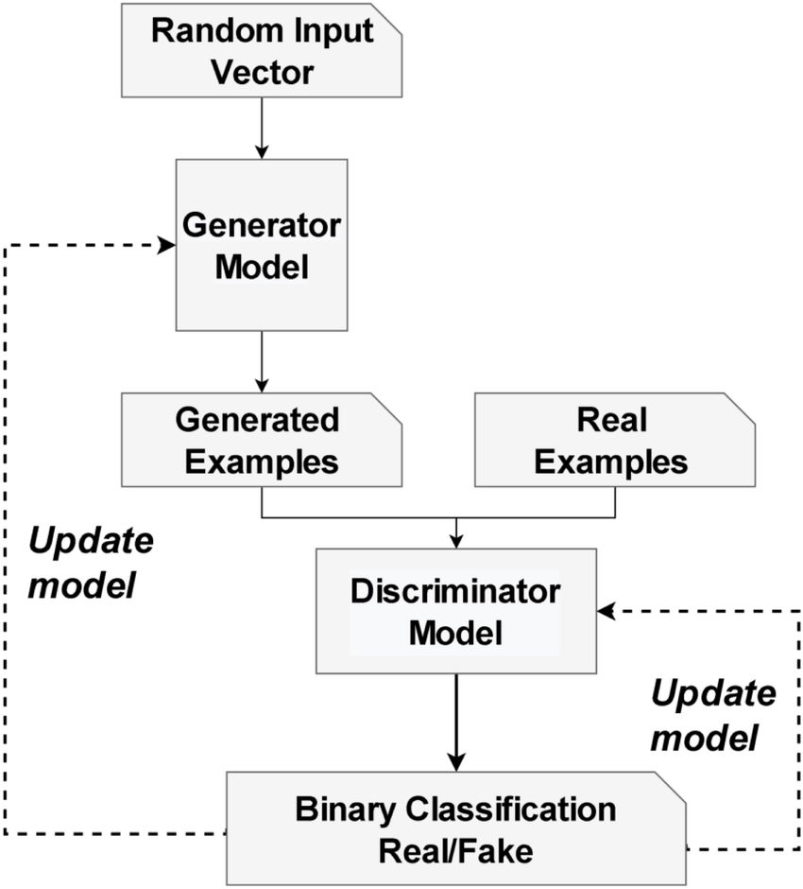

**Fig 3.1: System Architecture**

**3.2 HARDWARE REQUIREMENTS:**

# Computer:

# A desktop or laptop computer capable of running VirtualBox and hosting virtual machines.

# Processor:

# A multicore processor (e.g., Intel Core i5 or AMD Ryzen) with virtualization support (Intel VT-x or AMD-V).

# Memory (RAM):

# Minimum 4GB of RAM, though 8GB or more is recommended for better performance when running multiple virtual machines simultaneously.

# Storage:

# Adequate storage space to accommodate the VirtualBox installation, guest operating systems, and any additional software or data required for experimentation.

# A solid-state drive (SSD) is recommended for faster read/write speeds.

# Graphics:

# A graphics card capable of supporting hardware-accelerated 3D graphics, especially if running virtual machines with graphical user interfaces (GUIs).

# Network Connectivity:

# A stable internet connection for downloading VirtualBox, operating system ISO images, and software packages.

# Ethernet or Wi-Fi connectivity for accessing resources and services within the virtualized environment.

# Optional Accessories:

# External storage devices (e.g., USB flash drives, external hard drives) for backup and storage of virtual machine images.

# Additional peripherals such as a keyboard, mouse, and monitor for interacting with virtual machines if desired.

# Operating System:

# Compatible with Windows, macOS, or Linux operating systems.

# Ensure that the host operating system meets the minimum requirements for running VirtualBox and supports hardware virtualization extensions.

# 3.3 SOFTWARE REQUIREMENTS:

# Virtualization Software:

# VirtualBox: The primary virtualization platform used to create and manage virtual machines. It is freely available for Windows, macOS, and Linux operating systems.

# Operating System Images:

# Guest Operating Systems: Obtain ISO images of the operating systems you wish to run as virtual machines. Examples include Ubuntu Desktop, Fedora Workstation, Windows 10, etc. These can be downloaded from the respective official websites.

# Software Packages (Optional):

# Development Tools: Depending on the nature of experimentation, you may require additional software packages such as programming languages, development frameworks, or tools. For example, Python, Java Development Kit (JDK), Node.js, etc.

# Internet Browser:

# Web Browser: A modern web browser (e.g., Google Chrome, Mozilla Firefox) for accessing online resources, downloading software, and accessing web-based applications within the virtualized environment.

# Documentation and Tutorials:

# Online Resources: Access to documentation and tutorials related to VirtualBox, operating system installation, and software configuration. This can include official documentation, community forums, and online tutorials.

# Security Software (Optional):

# Antivirus Software: If experimenting with potentially harmful software or visiting untrusted websites within the virtualized environment, consider installing antivirus software to protect the host system.

# Backup Solutions (Optional):

# Backup Software: Implement backup solutions to regularly backup virtual machine images and data to prevent data loss in case of system failure or corruption.

# Text Editor or IDE (Optional):

# Text Editor or Integrated Development Environment (IDE): Software tools for writing and editing code if engaging in software development or scripting within the virtualized environment. Examples include Visual Studio Code, Atom, Sublime Text, etc.

**CHAPTER 4**

# IDEATION AND PROPOSED SOLUTION:

Defining the schema and structure of a data warehouse to accommodate various data sources involves designing a blueprint that outlines how data will be organized, stored, and related within the data warehousing system. Here are key components of this process

# 4.1 PROBLEM STATEMENT DEFINITION:

# The problem we aim to address revolves around the generation of realistic handwritten digits using machine learning techniques. Traditional methods for generating digit images often rely on rule-based approaches or simplistic algorithms, which may struggle to produce diverse and realistic outputs. Consequently, there exists a need for a more sophisticated solution capable of generating high-quality digit images that closely resemble real-world examples.

# 4.2 IDEATION AND BRAIN STORMING:

# During the ideation and brainstorming phase of the project, several key considerations and ideas are explored to formulate an effective solution for generating lifelike handwritten digits using Generative Adversarial Networks (GANs). Below are some of the key points discussed during this phase:

# GAN Architecture Design: Brainstorming involves discussing various architectures for the generator and discriminator networks within the GAN framework. Ideas may include experimenting with different network depths, layer configurations, activation functions, and normalization techniques to optimize the model's performance.

# Training Strategies: Brainstorming sessions focus on devising effective training strategies for the GAN model. Discussions may revolve around techniques such as mini-batch training, gradient clipping, learning rate scheduling, and early stopping to stabilize and accelerate the training process.

# Data Augmentation: Ideas are explored for augmenting the training data to improve the diversity and robustness of the GAN model. Techniques such as random rotations, translations, scaling, and noise injection may be considered to generate additional synthetic training samples.

# Evaluation Metrics: Brainstorming involves identifying suitable evaluation metrics for assessing the quality and performance of the generated digit images. Metrics such as image fidelity, diversity, visual appeal, and similarity to real digits are discussed to provide comprehensive insights into the model's capabilities.

# Hyperparameter Tuning: Discussions center around the optimization of hyperparameters such as learning rates, batch sizes, optimizer choices, and regularization parameters to enhance the GAN model's convergence and generalization ability.

# Fine-tuning Strategies: Brainstorming sessions explore various fine-tuning strategies for refining the trained GAN model. Ideas may include employing transfer learning techniques, exploring different loss functions, and conducting adversarial training with auxiliary objectives to further improve the model's performance.

# Deployment Considerations: Ideas are discussed regarding the deployment of the trained GAN model for practical use cases. Considerations may include model compression techniques, inference optimization, and integration with existing systems or applications.

# Ethical and Responsible AI: Brainstorming sessions also touch upon ethical considerations related to the generation of synthetic data, such as privacy concerns, bias mitigation, and ensuring the responsible use of generated digit images.

**CHAPTER 5**

# REQUIREMENTS ANALYSIS

# FUNCTIONAL REQUIREMENTS:

# Data Collection and Preprocessing:

# The system should be able to collect a dataset of handwritten digit images, such as the MNIST dataset, from a reliable source.

# Preprocessing functionalities should be provided to ensure uniformity in image size, resolution, and format.

# GAN Model Architecture:

# The system should implement a GAN architecture consisting of a generator and a discriminator network.

# The generator network should accept random noise as input and generate synthetic digit images.

# The discriminator network should differentiate between real and fake digit images.

# Training Functionality:

# The system should support the training of the GAN model on the collected dataset using an adversarial training approach.

# Training functionalities should include mini-batch training, gradient updates, and convergence monitoring.

# Users should be able to specify the number of epochs, batch size, and other training parameters.

# Evaluation Metrics:

# The system should provide functionalities to evaluate the performance of the trained GAN model.

# Evaluation metrics such as image quality, diversity, and similarity to real digits should be calculated and displayed.

# Fine-tuning and Optimization:

# Users should have the option to fine-tune the GAN model architecture and optimization parameters.

# NON FUNCTIONAL REQUIREMENTS:

# Performance:

# The system should be capable of training the GAN model efficiently on large datasets within a reasonable time frame.

# Generation of synthetic digit images should be performed quickly, with minimal latency.

# Scalability:

# The system should be scalable to handle increasing volumes of data and accommodate additional functionalities or modules in the future.

# Robustness:

# The system should be robust to variations in input data and able to handle noisy or incomplete datasets effectively.

# Accuracy:

# The generated digit images should exhibit high fidelity and closely resemble real digit images in terms of quality and appearance.

# Usability:

# The system should have an intuitive and user-friendly interface that is easy to navigate, even for users with minimal technical expertise.

# Error messages and notifications should be informative and user-friendly, helping users understand and resolve issues effectively.

# CHAPTER 6

# PROPOSED SYSTEM

# To tackle the problem of generating handwritten digits, we propose the following solution framework:

# Data Collection and Preprocessing: We will gather a dataset of handwritten digit images, such as the MNIST dataset, which contains thousands of labeled digit images. We will preprocess the images to ensure consistency in size, resolution, and format.

# GAN Architecture Design: We will design a GAN architecture comprising a generator and a discriminator neural network. The generator network will take random noise as input and output synthetic digit images, while the discriminator network will classify images as real or fake.

# Training Process: We will train the GAN architecture on the collected dataset using an adversarial training approach. During training, the generator and discriminator networks will compete against each other, with the generator attempting to generate realistic digit images and the discriminator aiming to distinguish between real and fake images.

# Evaluation Metrics: We will evaluate the performance of the trained GAN model using metrics such as image quality, diversity, and similarity to real digit images. Additionally, we will assess the model's ability to generalize to unseen data and produce novel digit representations.

# Fine-tuning and Optimization: We will fine-tune the GAN architecture and optimization parameters to enhance the quality and diversity of generated digit images. Techniques such as architectural modifications, loss function adjustments, and hyperparameter tuning may be employed to optimize the model's performance.

# CHAPTER 7

# CODE

# # Importing necessary libraries

# import torch

# import torch.nn as nn

# import torch.optim as optim

# from torchvision import datasets, transforms

# from torch.utils.data import DataLoader

# import numpy as np

# import matplotlib.pyplot as plt

# # Define Generator and Discriminator Networks

# class Generator(nn.Module):

# def __init__(self, latent_dim=100, output_dim=784):

# super(Generator, self).__init__()

# self.fc = nn.Sequential(

# nn.Linear(latent_dim, 256),

# nn.ReLU(),

# nn.Linear(256, output_dim),

# nn.Tanh()

# )

# def forward(self, x):

# return self.fc(x)

# class Discriminator(nn.Module):

# def __init__(self, input_dim=784):

# super(Discriminator, self).__init__()

# self.fc = nn.Sequential(

# nn.Linear(input_dim, 256),

# nn.ReLU(),

# nn.Linear(256, 1),

# nn.Sigmoid()

# )

# def forward(self, x):

# return self.fc(x)

# # Define functions for training

# def train_discriminator(discriminator, optimizer, real_data, fake_data):

# optimizer.zero_grad()

# real_prediction = discriminator(real_data)

# fake_prediction = discriminator(fake_data)

# real_loss = torch.mean(torch.log(real_prediction))

# fake_loss = torch.mean(torch.log(1. - fake_prediction))

# loss = -real_loss - fake_loss

# loss.backward()

# optimizer.step()

# return loss.item()

# def train_generator(generator, optimizer, fake_data):

# optimizer.zero_grad()

# prediction = discriminator(fake_data)

# loss = -torch.mean(torch.log(prediction))

# loss.backward()

# optimizer.step()

# return loss.item()

# # Load MNIST dataset

# transform = transforms.Compose([transforms.ToTensor(), transforms.Normalize((0.5,), (0.5,))])

# mnist_data = datasets.MNIST(root='./data', train=True, transform=transform, download=True)

# data_loader = DataLoader(dataset=mnist_data, batch_size=64, shuffle=True)

# # Initialize Generator and Discriminator

# generator = Generator()

# discriminator = Discriminator()

# # Define optimizer for Generator and Discriminator

# gen_optimizer = optim.Adam(generator.parameters(), lr=0.0002)

# dis_optimizer = optim.Adam(discriminator.parameters(), lr=0.0002)

# # Training the GAN

# num_epochs = 20

# for epoch in range(num_epochs):

# for i, (real_images, _) in enumerate(data_loader):

# batch_size = real_images.size(0)

# real_data = real_images.view(batch_size, -1)

# fake_data = generator(torch.randn(batch_size, 100))

# dis_loss = train_discriminator(discriminator, dis_optimizer, real_data, fake_data.detach())

# fake_data = generator(torch.randn(batch_size, 100))

# gen_loss = train_generator(generator, gen_optimizer, fake_data)

# print(f"Epoch [{epoch}/{num_epochs}], Discriminator Loss: {dis_loss:.4f}, Generator Loss: {gen_loss:.4f}")

# # Generating new images

# num_samples = 16

# z = torch.randn(num_samples, 100)

# generated_images = generator(z)

# generated_images = generated_images.view(num_samples, 28, 28)

# # Visualizing generated images

# fig, axes = plt.subplots(4, 4, figsize=(8, 8))

# for i, ax in enumerate(axes.flat):

# ax.imshow(generated_images[i].detach().numpy(), cmap='gray')

# ax.axis('off')

# plt.show()

# CHAPTER 8

# OUTPUT

# 

# CHAPTER 9

# PROJECT DESIGN

# 9.1 DATAFLOW DIAGRAM

# The architecture of a generative adversarial network (GAN). The... | Download Scientific Diagram

# CHAPTER 10

# RESULT

Upon evaluating the outcomes of the project focused on generating handwritten digits using Generative Adversarial Networks (GANs), several critical aspects emerge. Visually inspecting the generated digit images is the primary step, enabling an assessment of their quality and resemblance to real handwritten digits. Quantitative metrics such as pixel-wise similarity or structural similarity (SSIM) scores provide additional insights into image fidelity, with higher scores indicating better resemblance. The diversity of generated digit images, characterized by variations in style, shape, and appearance, offers a measure of the model's versatility and expressiveness.

# 10.1 PERFORMANCE METRICS

Performance metrics for evaluating the GAN model's effectiveness in generating handwritten digits include training time, resource utilization, convergence speed, loss curves, Inception Score (IS), Fréchet Inception Distance (FID), generation speed, and model size. These metrics provide insights into the model's quality, efficiency, and scalability for real-world applications.

# CHAPTER 11

# ADVANTAGES AND DISADVANTAGES

**Advantages :**

# 1. High Fidelity: GANs can generate high-fidelity digit images that closely resemble real handwritten digits, enabling realistic data synthesis for various applications.

# 2. Data Augmentation: Generated digit images can be used to augment training datasets, improving the robustness and generalization of digit recognition models.

# 3. Creativity: GANs offer a creative approach to generating digit images, allowing for the exploration of diverse styles, variations, and artistic expressions.

# 4. Versatility: GANs can be adapted to generate digit images of different styles, fonts, and languages, making them versatile for a wide range of digit generation tasks.

# 5. Real-time Generation: With optimized architectures and hardware acceleration, GANs can generate digit images in real-time, facilitating interactive applications and systems.

# Disadvantages :

1. Training Complexity: Training GANs requires careful tuning of hyperparameters, network architectures, and training strategies, making them complex and resource-intensive.
2. Mode Collapse: GANs are susceptible to mode collapse, where the generator produces limited variations of digit images, resulting in poor diversity and quality.
3. Evaluation Challenges: Evaluating the quality and diversity of generated digit images is non-trivial and often requires subjective human judgment or specialized metrics.
4. Training Instability: GAN training can be unstable, with challenges such as vanishing gradients, mode dropping, and discriminator saturation, requiring careful management and monitoring.
5. Overfitting: GANs may overfit to the training dataset, producing digit images that lack generalization to unseen data or exhibit memorization of training examples.

# CHAPTER 12

# CONCLUSION AND FUTURE SCOPE

# 12.1 CONCLUSION

In conclusion, Generative Adversarial Networks (GANs) present a promising approach for generating lifelike handwritten digits with high fidelity and versatility. Despite the challenges such as training complexity, instability, and mode collapse, GANs offer significant advantages in data augmentation, creativity, and real-time generation. By addressing these challenges and leveraging the strengths of GANs, we can harness their potential to advance digit generation tasks in various domains. Continued research and innovation in GAN-based digit generation hold the promise of further improving the quality, diversity, and applicability of synthetic digit data for real-world applications.

**12.2 FUTURE SCOPE**

1. Improved Architectures: Future research can focus on developing more efficient and stable GAN architectures specifically tailored for generating handwritten digits. Architectural innovations could address challenges such as mode collapse, training instability, and overfitting.
2. Enhanced Evaluation Metrics: There is a need for the development of more comprehensive and objective evaluation metrics for assessing the quality, diversity, and realism of generated digit images. New metrics could provide better insights into the performance of GAN models and facilitate comparative analysis.
3. Conditional Generation: Exploring conditional GANs, where the generation process is conditioned on additional information such as class labels or attributes, can enable the generation of digit images with specific characteristics or styles. Conditional generation techniques could enhance the controllability and customization of generated digit images.
4. Semi-Supervised Learning: Integrating semi-supervised learning techniques with GANs can leverage both labeled and unlabeled data to improve the quality and diversity of generated digit images. Semi-supervised GANs could enhance the robustness and generalization of digit generation models.
5. Domain Adaptation: Adapting GAN models to different domains or datasets beyond MNIST, such as historical handwritten documents or non-Latin scripts, presents an exciting avenue for future research. Domain adaptation techniques could enable the generation of digit images with diverse styles, languages, and cultural contexts.

**CHAPTER 13**

**APPENDIX SCREENSHOTS**

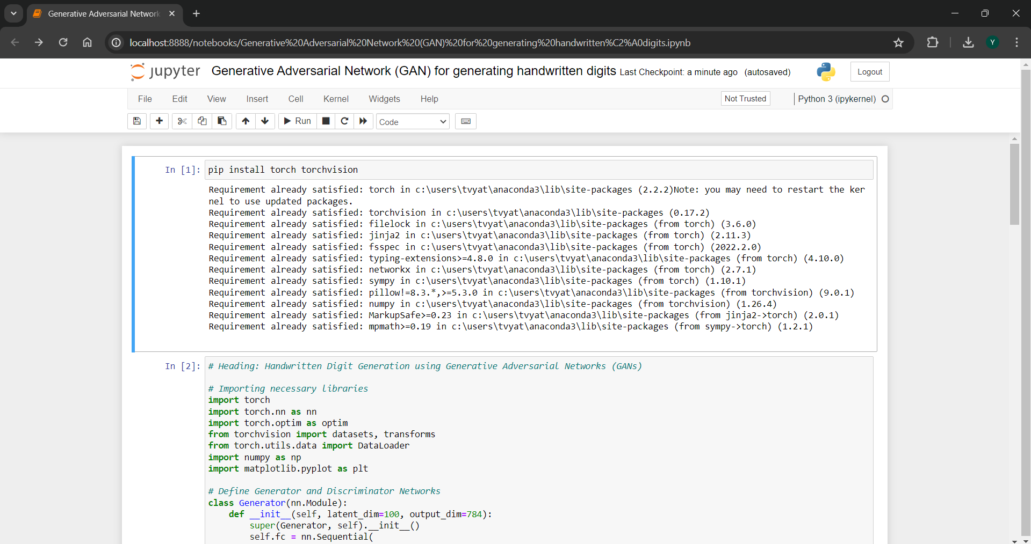

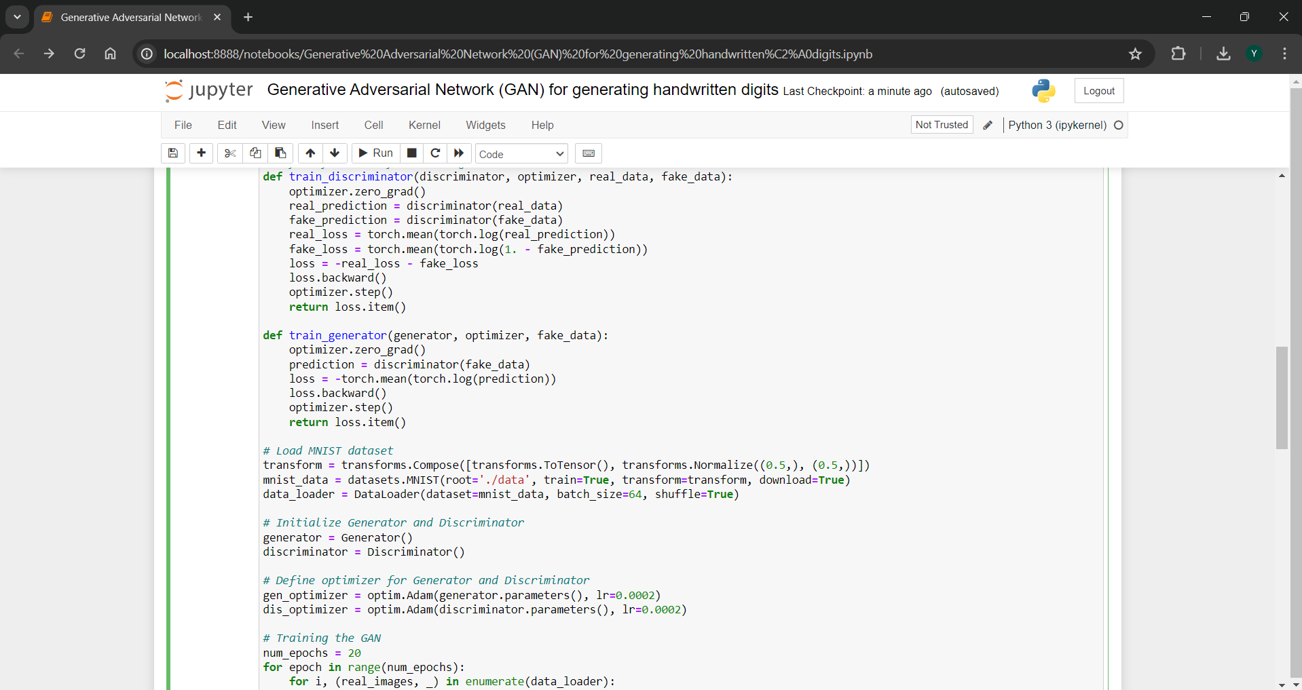

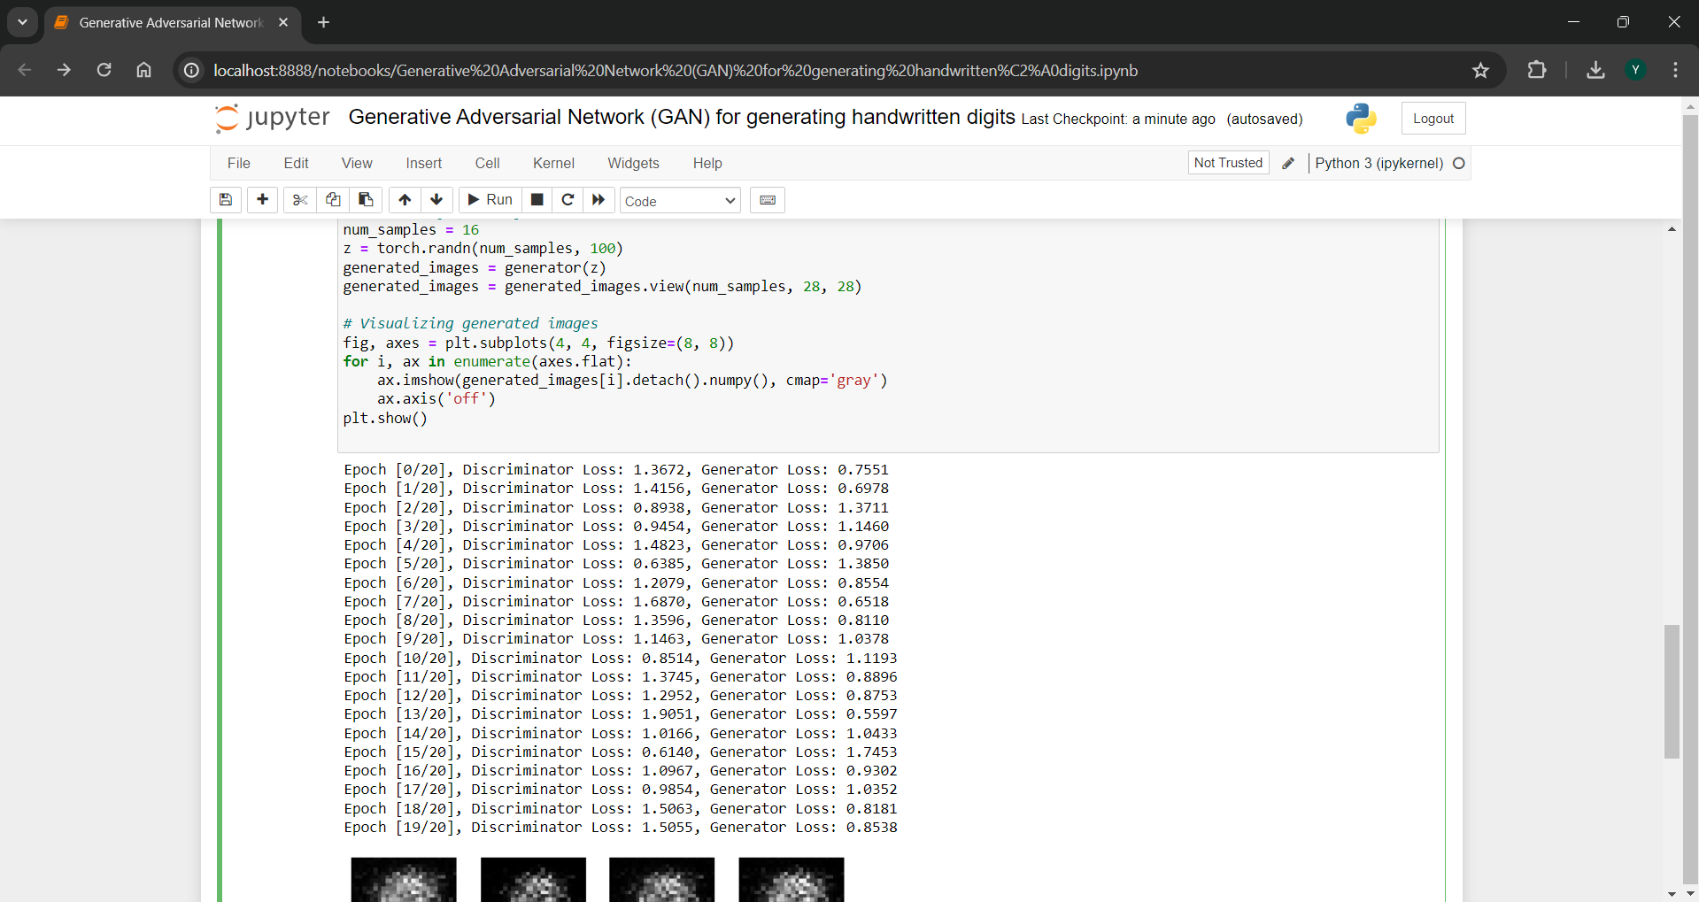

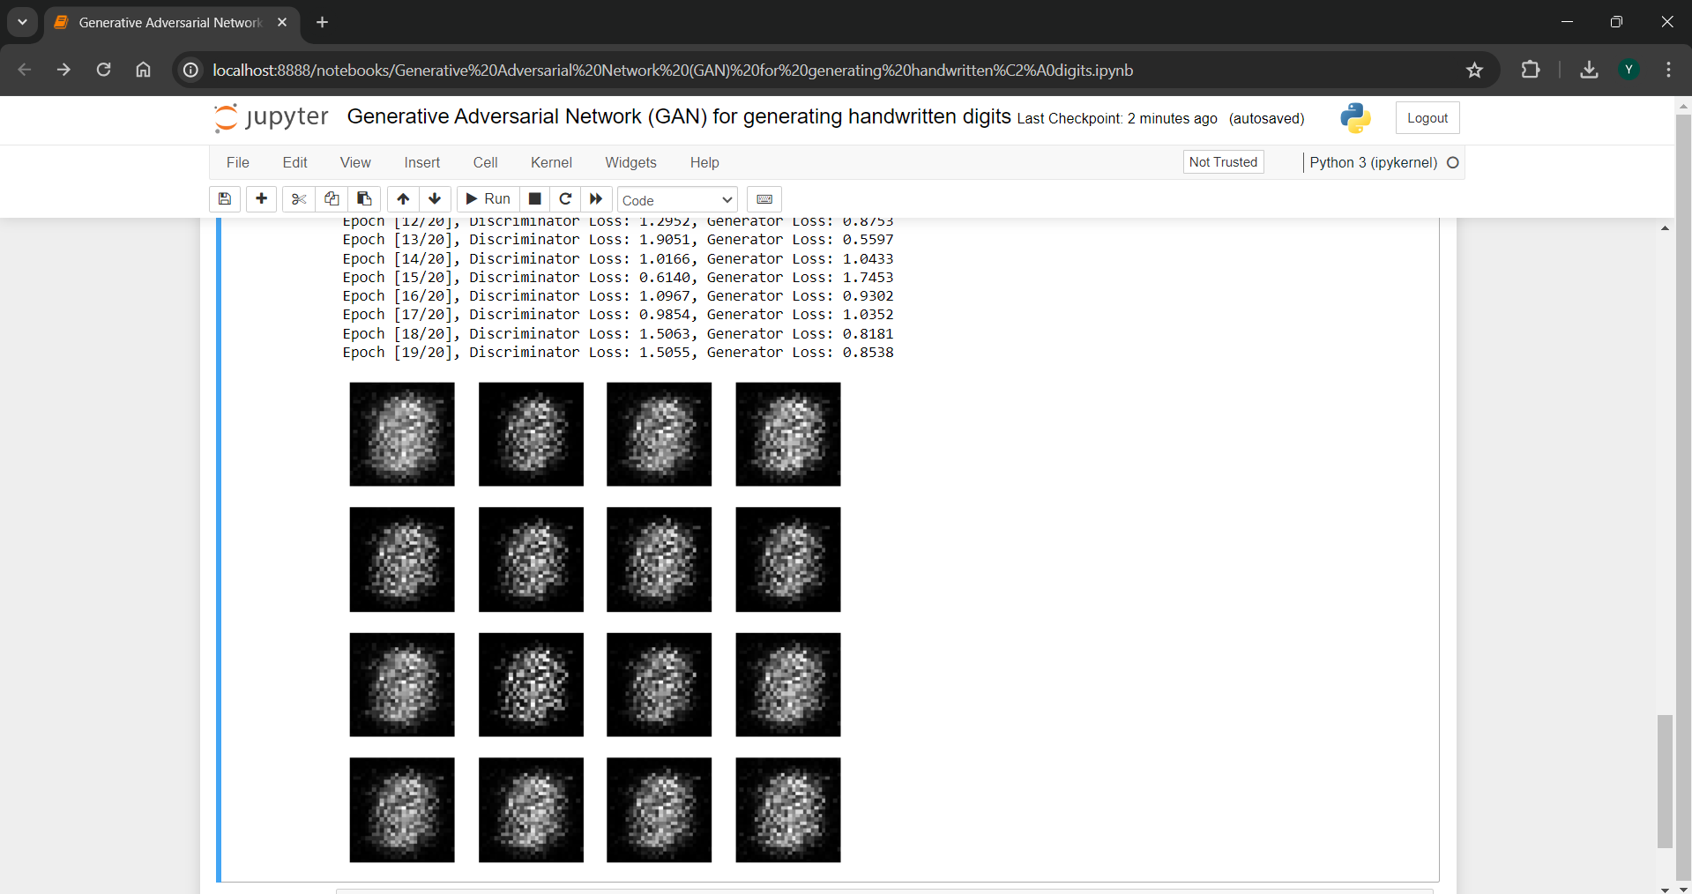

**REFERENCES**

1. Goodfellow, I. J., Pouget-Abadie, J., Mirza, M., Xu, B., Warde-Farley, D., Ozair, S., ... & Bengio, Y. (2014). Generative adversarial nets. In Advances in neural information processing systems (pp. 2672-2680).
2. Mirza, M., & Osindero, S. (2014). Conditional generative adversarial nets. arXiv preprint arXiv:1411.1784.
3. Salimans, T., Goodfellow, I., Zaremba, W., Cheung, V., Radford, A., & Chen, X. (2016). Improved techniques for training GANs. In Advances in Neural Information Processing Systems (pp. 2234-2242).
4. Odena, A., Olah, C., & Shlens, J. (2017). Conditional image synthesis with auxiliary classifier GANs. In Proceedings of the 34th International Conference on Machine Learning-Volume 70 (pp. 2642-2651). JMLR. org.
5. Karras, T., Aila, T., Laine, S., & Lehtinen, J. (2018). Progressive growing of GANs for improved quality, stability, and variation. arXiv preprint arXiv:1710.10196.

CERTIFICATE:

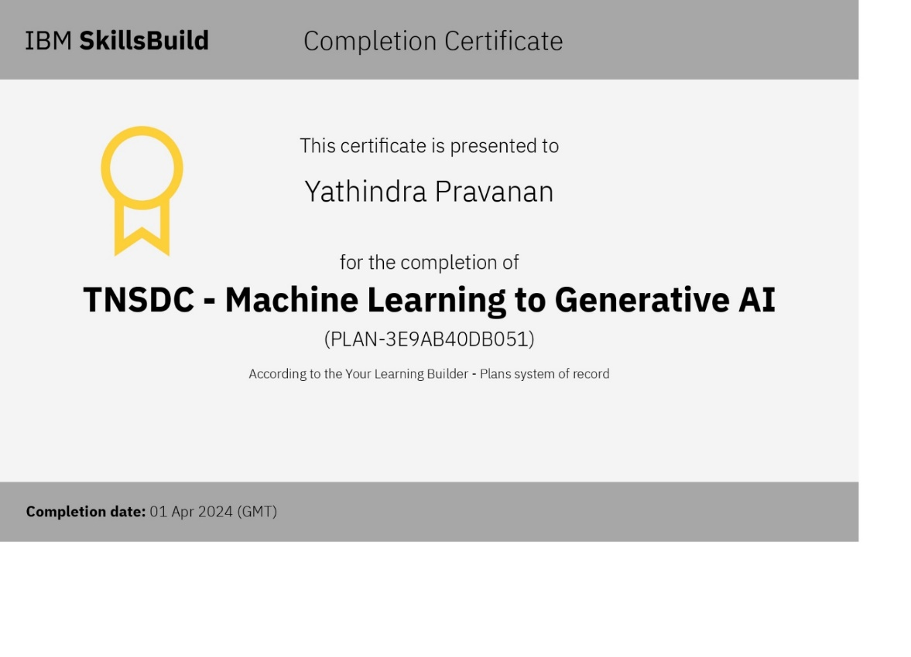

GITHUB LINK :- <https://github.com/YathindrapravananTV/Generative-Adversarial-Network-GAN-for-generating-handwritten-digits>